Agenda:

1. Mid-Sprint Progress Check is coming up:
   * We’re scheduled for 2/21/23 (next Thursday)
   * Required:
     + Timesheet
     + Team progress since sprint planning meeting
     + Expected goals by demo day (3/2/23)
     + To-do Checklist:
       - (?) US
       - (?) US-map
       - (?) Gh project setup/initialized - our scrum board? (#4)
       - ___?
   * What are our goals beyond dev environment setup for Sprint 2?
   * **Chris set GH Project in client repo**
2. Additional “Epic” (S2 goals?) propositions:
   * tutorials/learning react and/or Js?
     + **Yes, good secondary goal**
   * Earmark relevant topics–maybe start a doc and begin sorting features?
     + Maybe pick out/separate/assign priority/generally go over whichever WFs are most relevant to implement based on what we know currently while we’re in class?
     + If so, probably best to write as US/US-map first? Alternatively, GH Project (#4)
   * Plan/brainstorm (pre-) testing
     + Roughly identify tasks (make US’s + US map)
     + Learn/practice figma tools to use WFs for testing
       - Does anyone have any prior experience w/ figma?
       - Propose # or range of users to run tests with
       - Does the figma already have that simulated flow or will we need to build it (what Dr. Cook mentioned for running user tests without needing to code it up)
     + **A little too early for this, but next**
3. Check-ins/Stand-up:
   * Change time: 12:00 -> 23:59?
     + If so remember to update contract in drive and on gh
     + **approved**
   * Any benefit to scheduling more live time?
     + If so, when?
4. Regarding repo:
   * Should we migrate to the client PP repo?
     + Pros:
       - GH projects functionality is pretty dependent upon being set up at least within the same organization
     + Cons:
       - Already started using the current one
       - Already submitted the link on canvas
   * To-do: create Sprint 2 folder in repo
   * **Continue using team repo for sprint files, but projects are set up in client’s repo**
5. Individual:
   * Chris: did the VM work out?
     + **VM set up; still same error with git:// prefix**
   * Andre: request copy of /backend_master/config/package.json
     + **done**
   * Elliott: as promised, no progress since meeting (maybe something before class today?)
     + **Team has been informed**

Requested:

Does Julio have a helper folder with errors.js? **No**

Julio’s React version - all 18.2.0

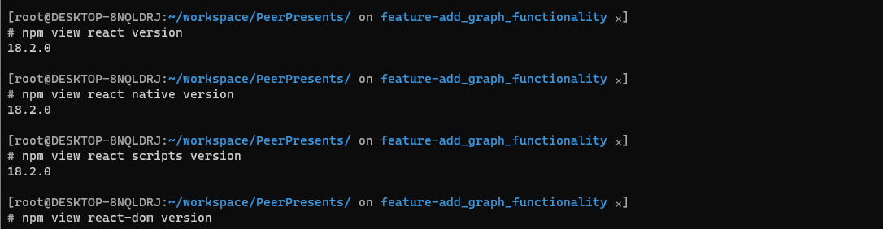

Action Items:

* Setup, setup, setup! Top priority!